JAVA Notes – Punit

**Revision:**

|  |
| --- |
|  |
|  | // variables: int speed = 100; speed(variable); String name = "Alex", (name is the variable) |
|  | // Data types (Primitive): int, String, char, boolean, float, LocalDate(java.time.LocalDate) |
|  | // Operators: +, -, *, /, ++ |
|  | // Common String functions: indexOf(" "), concat(parameter), length(), toUpperCase() |
|  | // Common Math functions: Math.abs(param), Math.max(para1, para2), Math.min(para1, para2), |
|  | Math.sqrt(para1), Math.random() |
|  | // Booleans: true or false values, ex: bool flag = true; |
|  | // if..else statement: if(condition) {} else {} |
|  | // Switch statement: switch(value) {case 1: break;} |
|  | // for loop: for(int i = 0; i<number;i++){} |
|  | // for each loop: for(String i: array){} |
|  | // while loop: while (condition) {} |
|  | // do while loop: do {} while(condition) |
|  | // break, meaning stop in a loop. while () { if(i==4){ break; } } |
|  | // continue, meaning skip and go to next. while(condition) { if(i==4){ continue; } } |
|  | // Arrays: it a collection of any datatype. |
|  | // Method: to keep repetative logic/operation in one place and to reuse it for different inputs. |
|  | // public : it can be called or accessed by anyone(any other method) |
|  | // void : it returns nothing |
|  | // () : input parameters, separated by comma (,,,) |
|  | // method overloading: |
|  | // 1. number of input parameters are changing |
|  | // 2. Data type is different |
|  | // 3. Return type is different |
|  | --- |
|  | // Class, Objects, Class Methods, Constructors (default values) |
|  | // Java Packages : Built-in (java.util.*) and User-defined packages(citi.May06.Employee) |
|  | // Java User Input(System.util.Scanner): to read the user provided input. |
|  | // OOPS: Object Oriented Programming Languages(Java, C#, Python, Go) |
|  | // Modifiers |
|  | // private: It can only be accessed only in the same class. |
|  | // public: It can be accessed inside or outside class. |
|  | // protected: It can be accessed within same package and subclasses. |
|  | // 4 Major pillars of OOPS: |
|  | - Encapsulation: to group information or hide information from users (Getter and Setter methods) |
|  | - Inheritance: Passing of attributes and methods from Parent to Child class. EXTENDS. |
|  | - Polymorphism (Run-time Overloading): A method which behaves differently based on the parent-child relationship of two classes |
|  | - Abstraction: Data hiding |
|  | - class: You can't instantiate a class |
|  | - method: Abstract methods can't have a body (can't exist without an abstract class) |
|  | //Interface:skeleton which a class should follow.(Interface would only contain declarations, you can't provide definition(body) for any function) |
|  | --------------------------------------------------------------------------------------------------------------------------------------- |
|  | ArrayList: It's resizable array inlike the Array (java.util.ArrayList) |

JAVA

W3 SCH EXERCISE

SYNTAX

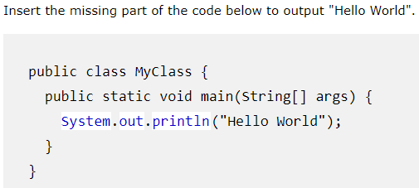

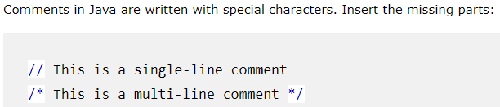

VARIABLES

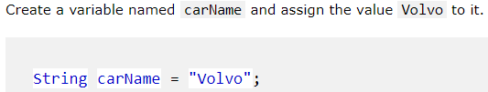

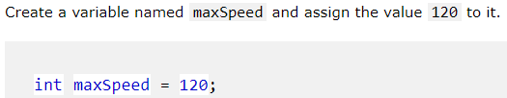

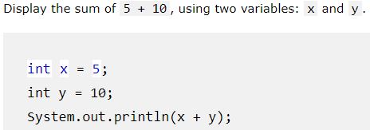

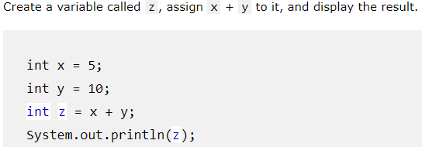

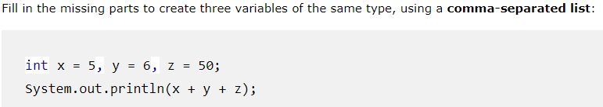

DATA TYPES

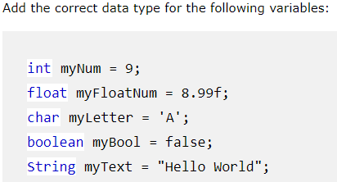

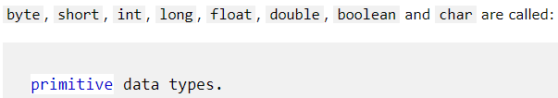

OPERATORS

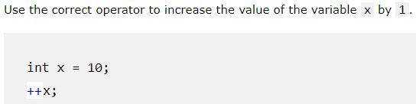

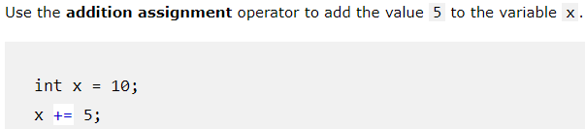

STRING

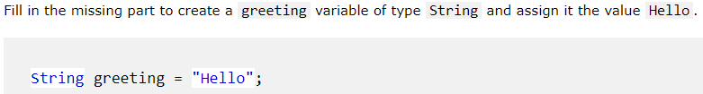

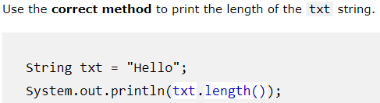

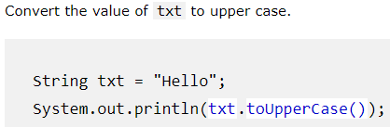

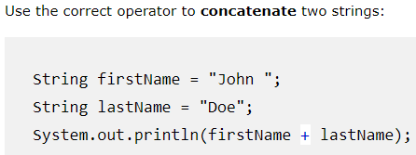

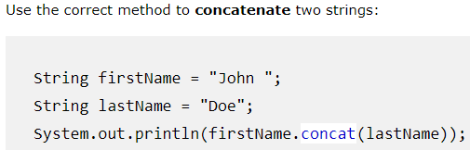

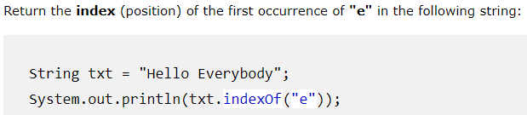

MATH

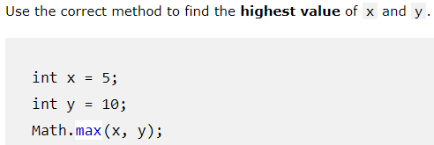

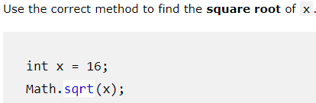

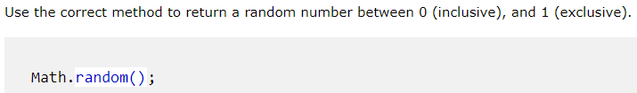

BOOLEAN

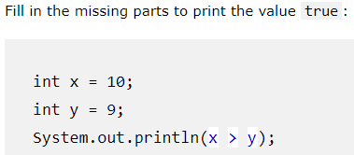

IF ELSE

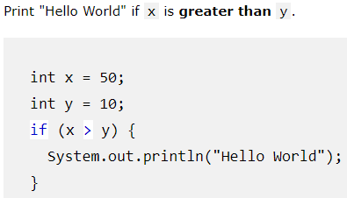

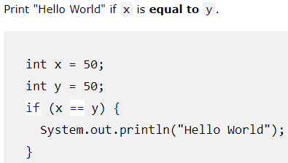

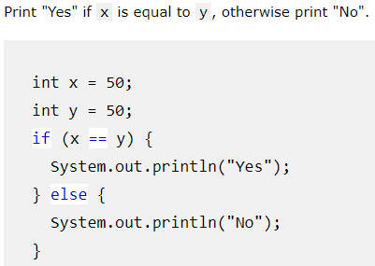

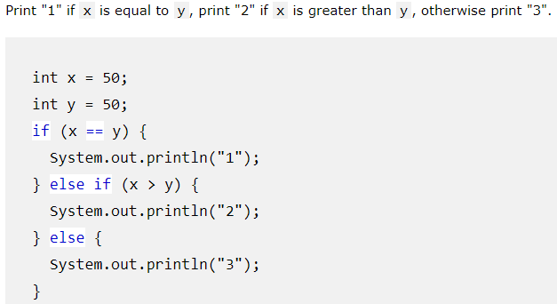

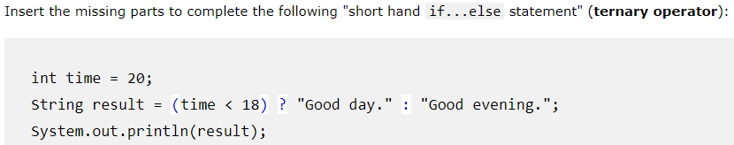

SWITCH

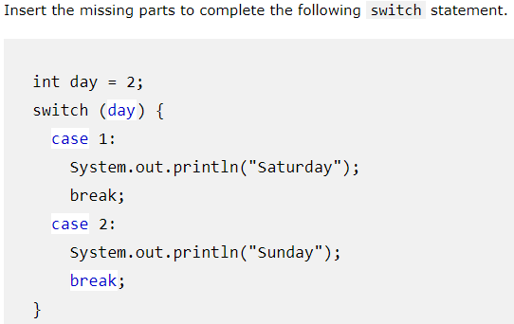

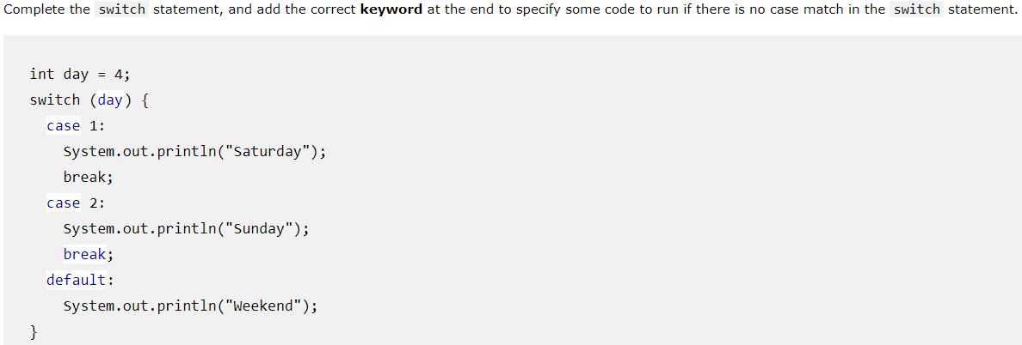

LOOPS

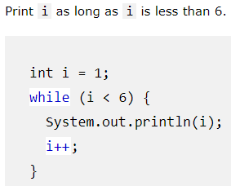

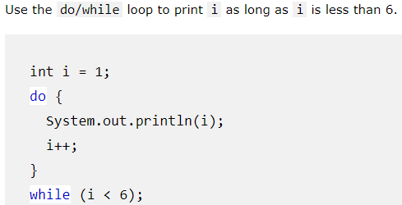

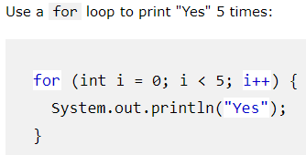

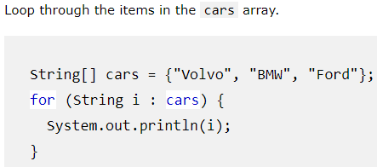

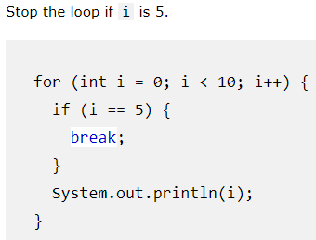

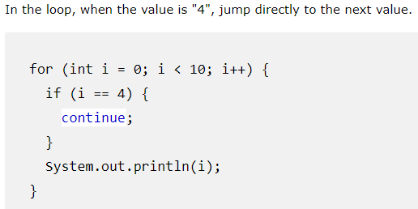

ARRAYS

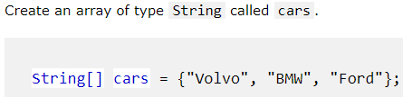

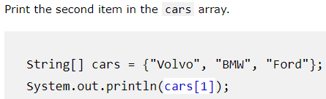

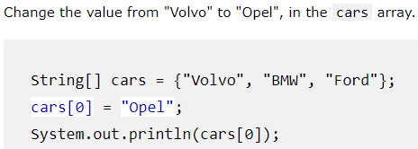

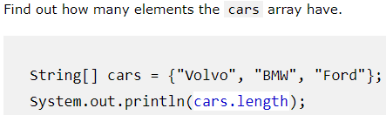

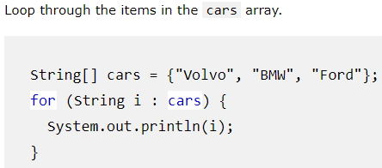

METHODS

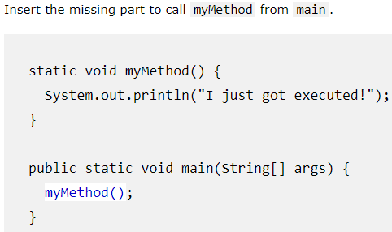

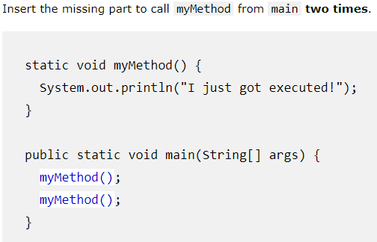

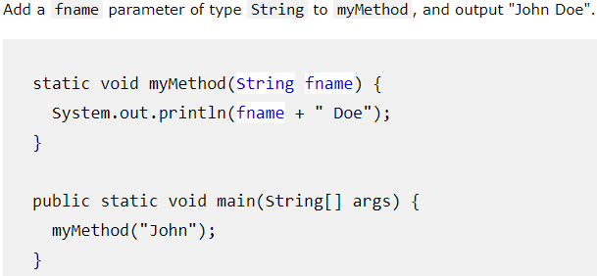

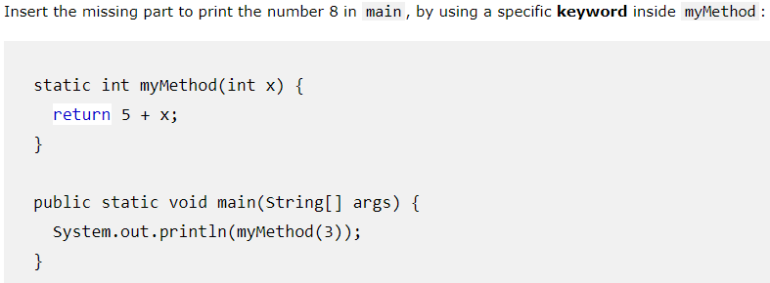

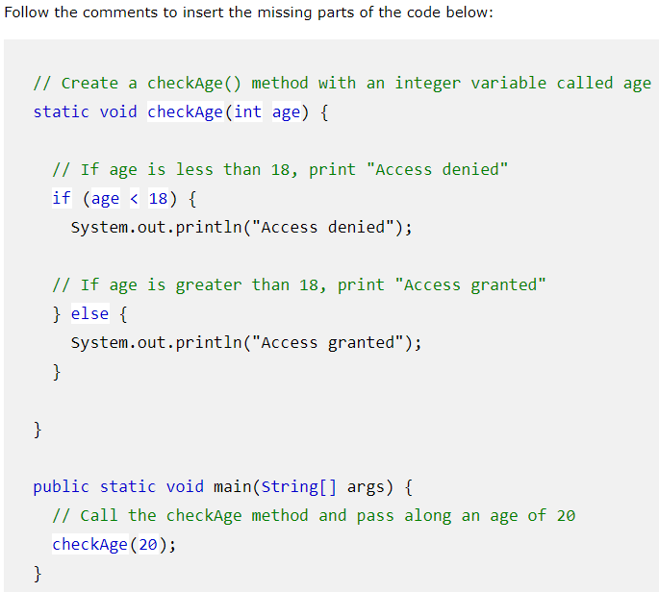

CLASS/OBJECT

